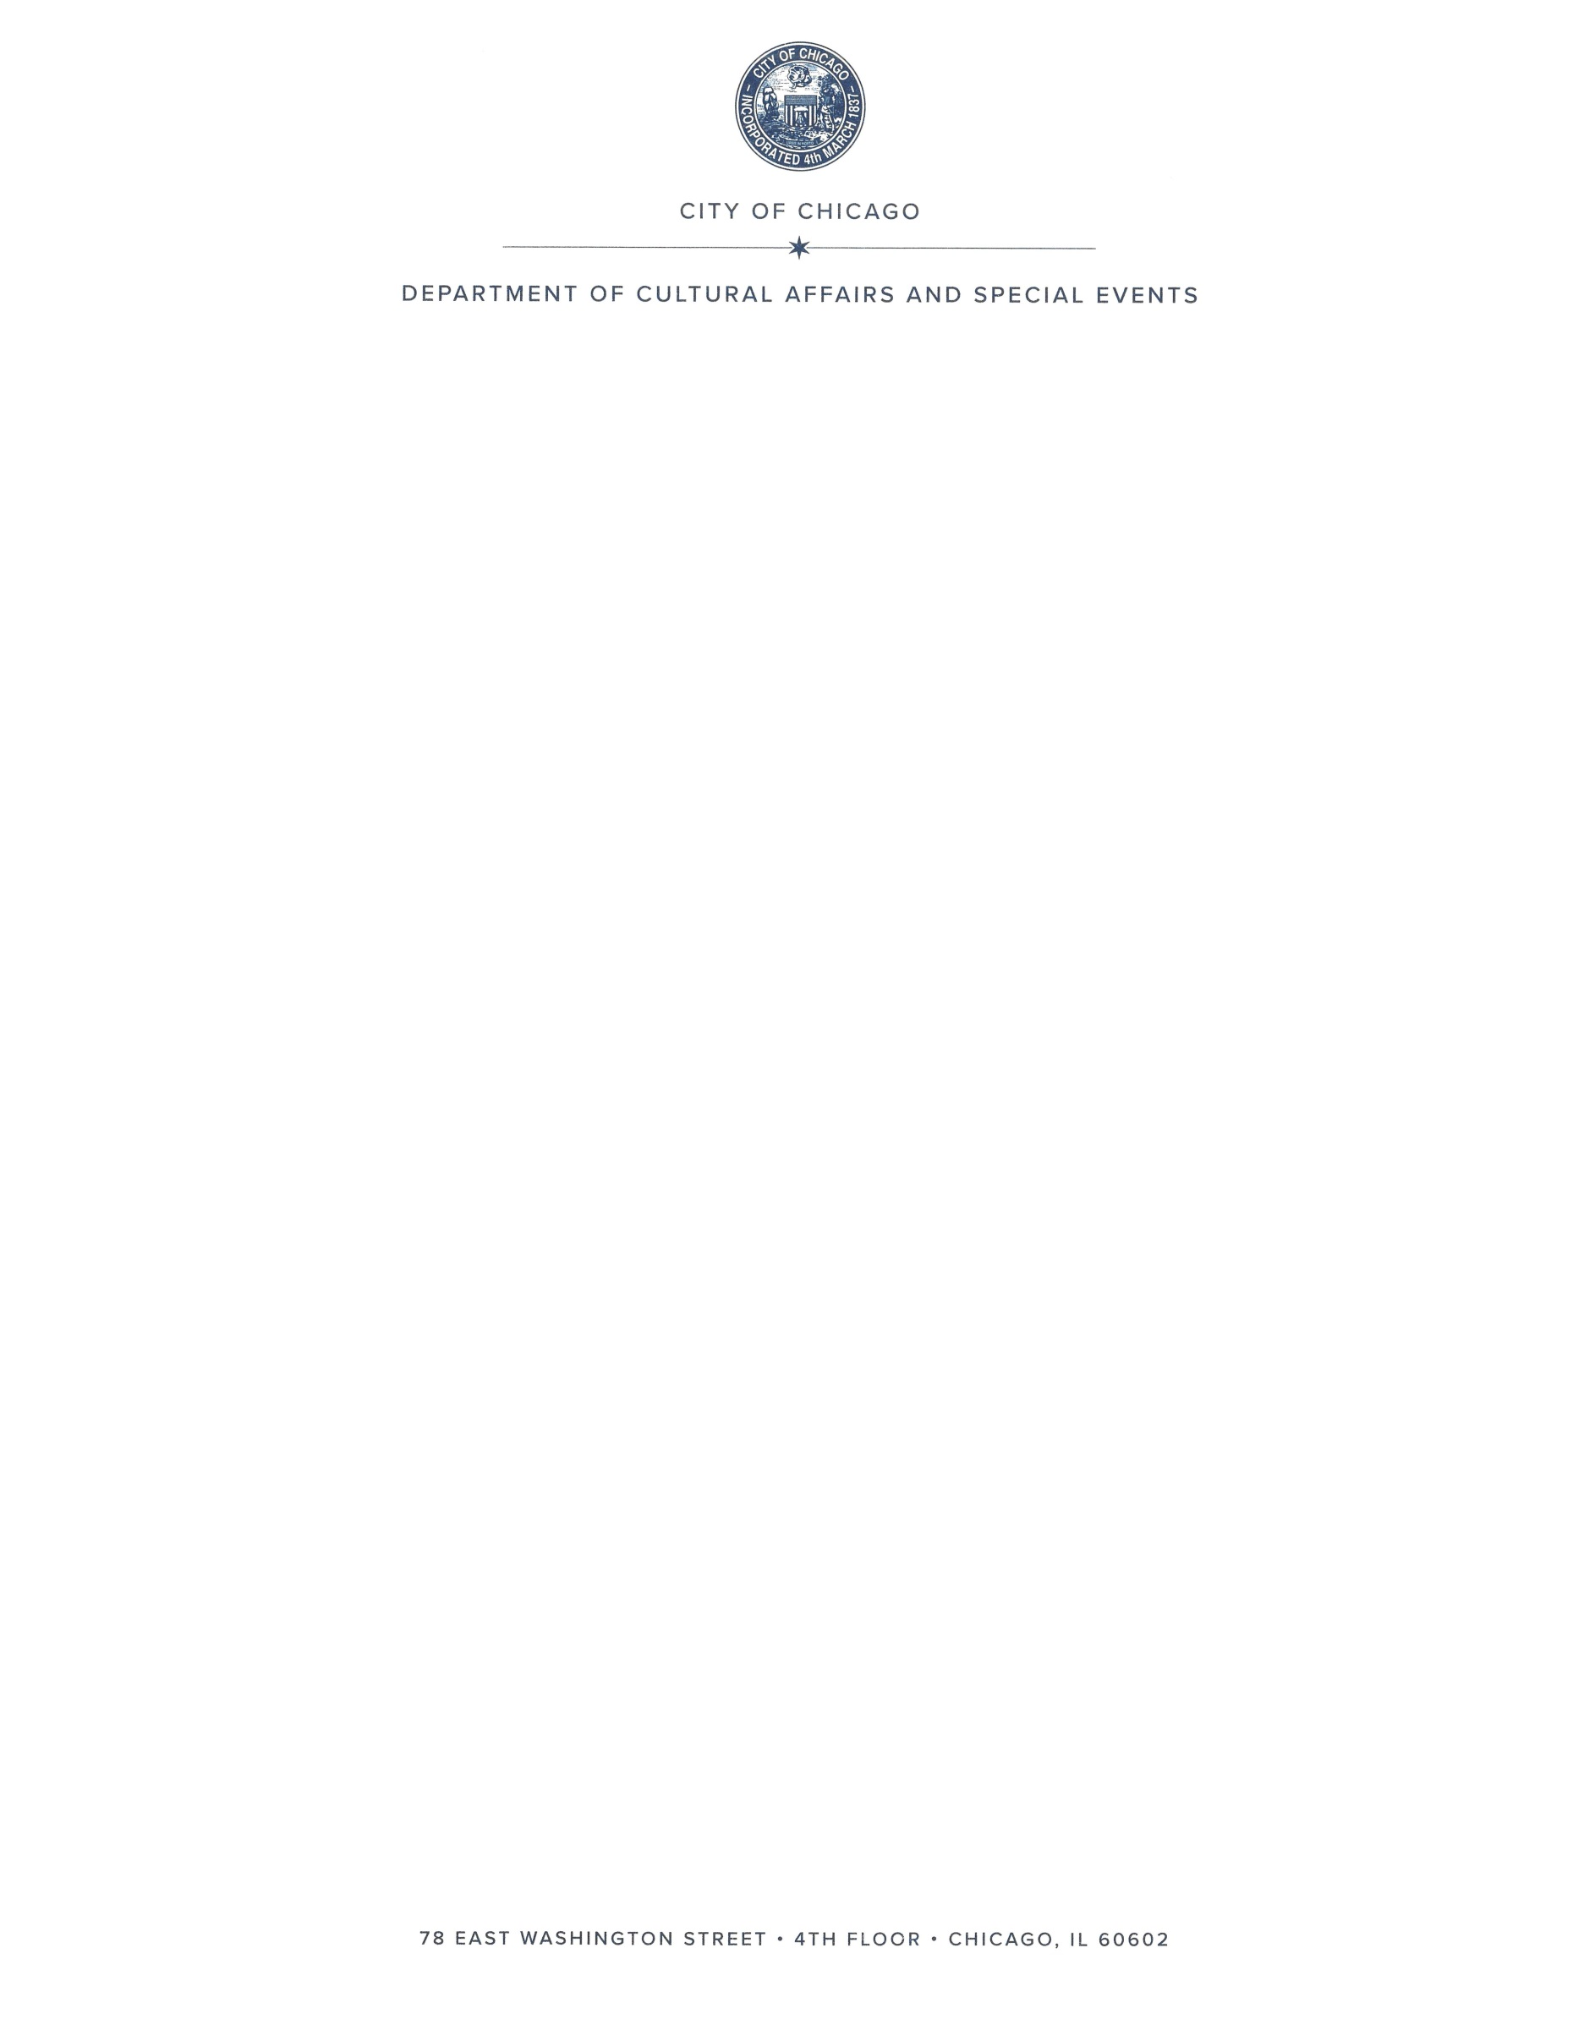
[Healthcare facility name]
[address]
[phone number]
[Date]
To Whom It May Concern,
This letter is to verify that [eligible healthcare worker name] is employed at [name of healthcare facility] as a [position/title] in the [department name]. Additionally, [eligible healthcare worker’s name] has been identified as a healthcare worker eligible for hotel accommodation due to direct contact with COVID-19 positive or symptomatic persons.
This letter serves as confirmation that [eligible healthcare worker’s name] has been determined eligible for a hotel accommodation by [name of healthcare facility].
Please do not hesitate to contact [healthcare facility contact] with any additional questions or concerns.
Sincerely,
_________________________
Printed Employee Name

__________________________
Employee Signature

____________________________

Printed Hospital Authorized Name

___________________________

Authorized Signature

Call the following hotels, in advance, to secure a reservation:
The Godfrey Hotel The LondonHouse Hotel

312.649.2000 312.357.1200

Press “2” Front Desk Press “0” for Front Desk

